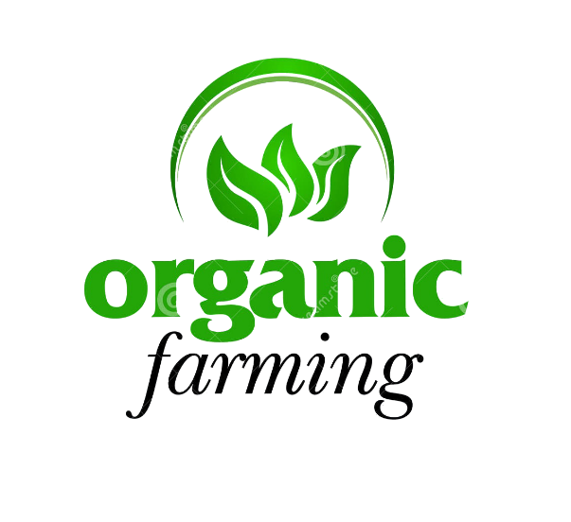

PROJECT NAME
Humanitarian Projects

NAME: FULL NAME
EMAIL: EMAIL ADDRESS
PHONE: PHONE NUMBER
DATE: January 3, 2022
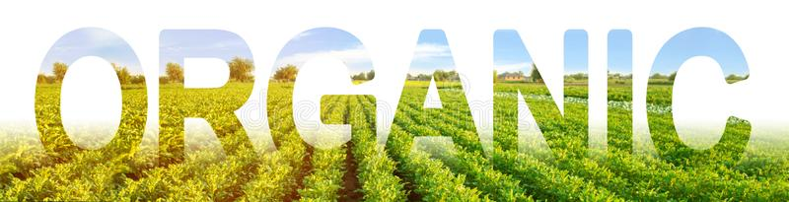
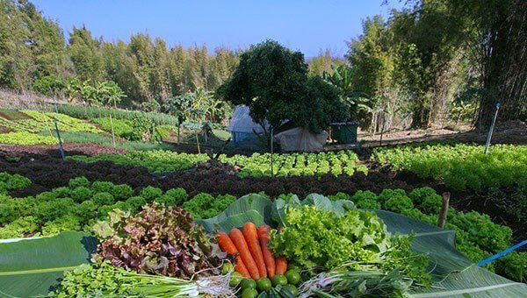
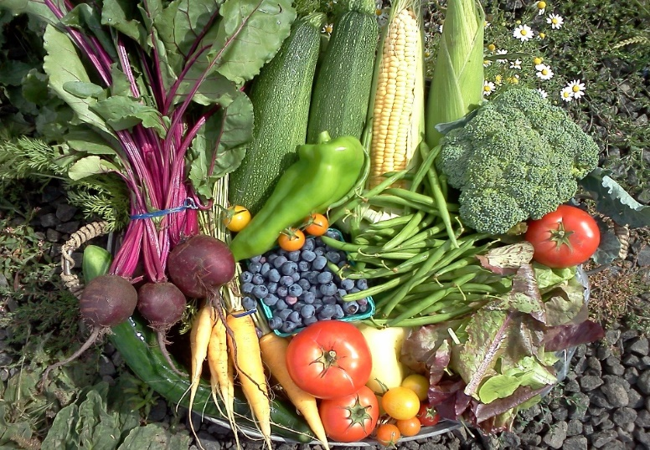
PROJECT: ORGANIC FARMING – Produce Organic fruits and vegetables to help supply our local community and eventually other communities with fresh food not genetically modified. NON-GMO
With the Redemption of the Zim Bonds, and exchange of currency at the best rate we will provide funding to the following multigenerational projects that will help people of all ages and local community and eventually other communities with fresh food not genetically modified.

ISSUES: Harmful effects on the human body. It is believed that consumption of these genetically engineered foods can cause the development of diseases which are immune to antibiotics. No human studies have been done and yet human diseases are getting worse, health and allergies take over more of the population.

Organic farmers, ranchers, and food processors use agricultural methods intended to preserve the environment. USDA organic regulations restrict the use of certain conventional tools such as synthetic fertilizers and pesticides.
The organic industry is one of the fastest growing agricultural segments in the United States. Organic farming yields such vital benefits as preservation of soil’s organic composition.
Organic farmers utilize practices that:
- Maintain and improve fertility, soil structure and biodiversity, and reduce erosion
- Reduce the risks of human, animal, and environmental exposure to toxic materials
- Fine-tune farming practices to meet local production conditions and satisfy local markets
- Organic farming is based on natural methods for keeping weeds and pests down, and no synthetic pesticides are used.
- When you buy organic, you therefore save yourself the risk of residues of pesticides.
- The certified organic ingredients used in the NATULIQUE products are therefore not only beneficial for natural reasons, but also because they have not been exposed to chemicals during production.

A RECENT STUDY suggested that community gardens were perceived by gardeners to provide numerous health benefits, including improved access to food, improved nutrition, increased physical activity and improved mental health. Community gardens were also seen to promote social health and community cohesion.

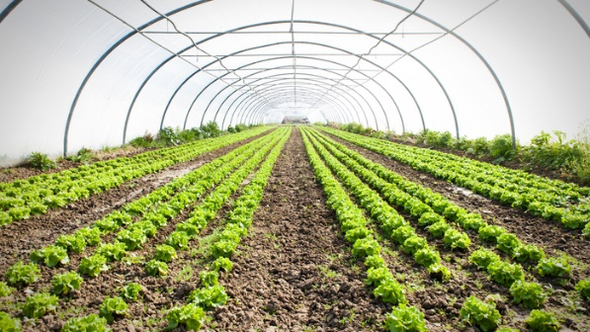
Community greenhouses for these areas for year -round healthy food. Would like to see it work via a volunteer system, work in greenhouse, and receive the foods for free. Obviously will need a few employees and knowledge to get it off the ground.

By providing access to fresh organic produce, opportunities for physical activity, contact with nature, and neighborhood meeting places, these gardens promote physical and mental health in communities with diverse residents.”

Types of Community Gardens
- Plot Gardens (divide into individual plots)
- Cooperative Gardens (work as a team on one large garden)
- Youth Gardens.
- Entrepreneurial Market Gardens (sell produce)
- Therapeutic Gardens.
Done properly community gardens can make money along with providing better and healthy food for an area. But doing this the profits from selling the foods that are in abundance can help to make this a perpetual project helping it to be self-sustaining.
Other community projects to clean areas and build ADA ramps for people will also be planned.
Purchase farmland and produce sustainable crops of hemp, fruit, vegetables for the homeless
Our Goal is to purchase A Large Home Property or several hundred Acres for our horses and grow sustainable Crops such as Hemp, Fruit Trees and other sustainable, rotatable crops that will benefit the local area, and provide needed products.

GREENHOUSES FOR COMMUNITY’S SAFE FOOD SOURCE
Additionally, we plan on putting up green houses to grow food for the local communities to feed those who cannot afford fresh vegetables and fruit, also to supply our Homeless communities’ year-round food. These will go both on the Property for the Homeless as well as our own Property.
Too many food products currently contain harmful chemicals and fertilizers, and many are GMO modified. Families in communities and farmers everywhere need to be growing more and more of their own chemical free and safe food. There are two growing seasons as the winter in most states is too cold for growing gardens.
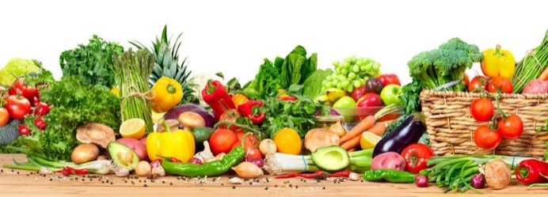
We propose to target subdivisions and small communities and install fully equipped greenhouses. We will start with ten greenhouses per county. These greenhouses will be large and will service a whole community or subdivision. It is a way to bring people together to take charge of their health and safe food source. We hope it will lead to fruit orchards and other home-grown healthy alternatives.

We are looking at 10 greenhouses per county in my state. This project can grow with time. We are looking at 20 years to get these counties serviced, maybe longer. It depends on the greenhouse companies' ability to manufacture and install quickly. There will be teams meeting with the different communities and subdivisions to find out the interest, need, permits needed and permissions needed.
These greenhouses will help enable communities to become food source independent. We hope to renew the project in 20 years to include other states. The project can lead to canning classes, socializing and farmers markets being brought back into communities.
- Cost estimate: based on 32’x54’2 ½" size
- Base cost: $145,410 (before taxes or delivery) some options chosen
- Installation: add 30%
- Cement slab: $8 square foot
- Climate control: $18,000 each (heat and cool)
- Engineering:
- All numbers except the base cost will change based on location and economy. Example, Houston would not need heat part of climate control...it's cheaper for teams to rent motel in Amarillo than it is in Houston...all those factors determine installation prices.
- Costs Listed do not include Land Purchase or Employees at this time until Project Managers Can be Consulted.
All Projects as outlined WILL BE A MULTI-GENERATIONAL PROJECTS With employing a great deal of local help, providing a needed service, and responsible service to children, adults and the elderly FOR Many Generations To Come.
REFERENCES:
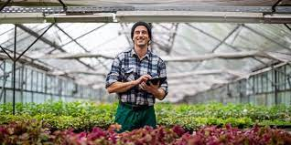
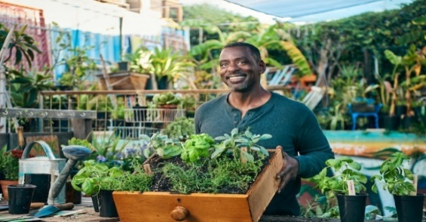
https://nifa.usda.gov/topic/organic-agriculture https://www.ncbi.nlm.nih.gov/pmc/articles/PMC3791249/
