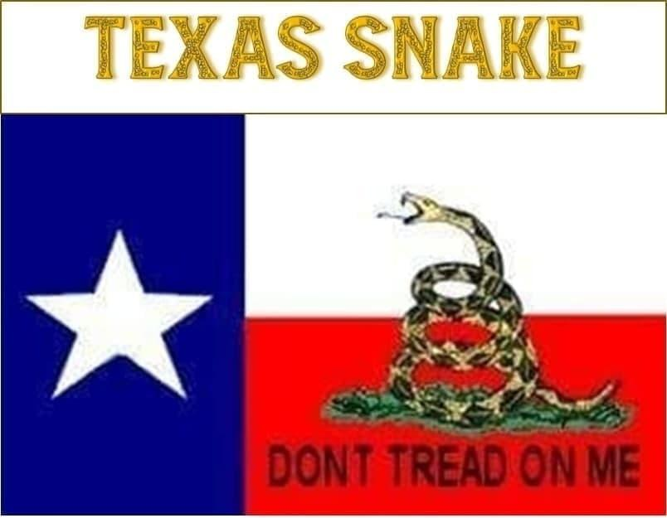
Texas Snake Bio:
To give a frame of reference for what I am posting in my room and my training around financial planning, I would like to provide this brief bio. I graduated from college in 1968 with a double major in investment banking and finance and industrial psychology. My first job out of college was a pilot with TWA from my graduation until 1971 at the end of the Vietnam conflict. After my time as a pilot, I became registered with the New York Stock Exchange (NYSE) due to issues in maintaining my status as a pilot.

In order to take my exams, six months of training was needed at the New York Institute of Finance. At that time I took the exams and became registered with the NYSE and SEC. At that time I also obtained the series 7 license and got started in the insurance business as well with the group 1 life insurance license. The next 46 years were spent owning my own company and working with several brokerage houses including E.F. Hutton. In 1978 I truly became my own broker dealer. The last several years have been spent focused on the series 26 securities license.

I was brought into the currency investment market in 2004. The person that made me aware of this was my roommate in New York from the time I was preparing for my exams. We are both retired now and I look forward to you all enjoying and using what I have to share with the community.

Texas Snake Audio Bio

