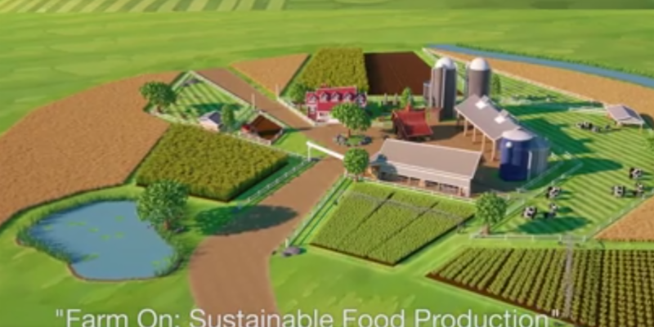

SUSTAINABLE FARMING
Humanitarian Project

Name: FULL NAME
Email: EMAIL ADDRESS.COM
Phone: 405-308-2473
Date: January 3, 2022

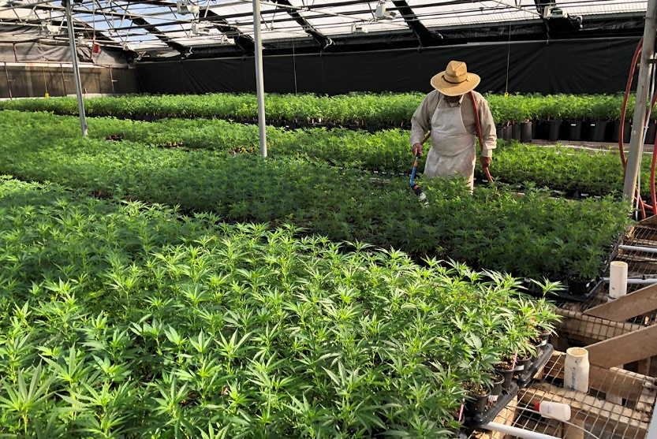

PROJECT DESCRIPTION Purchase farmland and produce sustainable crops of hemp, fruit, vegetables for the homeless
Our Goal is to purchase A Large Home Property or several hundred Acres for our horses and grow sustainable Crops such as Hemp, Fruit Trees and other sustainable, rotatable crops that will benefit the local area, and provide needed products.
One of the textile types we hope to utilize for this adventure is HEMP. Hemp is easily renewable and is a crop that is considered a permaculture crop. Industrial hemp is an example of such plants. It is easy to grow and relatively eco-friendly compared to other crop species. The market for hemp-related products has grown exponentially. This market is expected to grow for the next few years now that the 2018 Farming Bill legalized hemp production by licensed growers.
Recent market research done by Brightfield Group revealed that the CBD market is likely to hit $22 billion by 2020. With these staggering projected sales numbers, hemp growers are looking to get in on these potential profits that the industry has to offer. The production of this fabric is inherently environmentally sustainable as is evidenced by the fact that human beings have produced hemp fabric for thousands of years without incurring any major ecological calamities.
Permaculture is perceived as a sustainable approach to farming that offers a permanent solution to various problems that planet earth faces. Its core objectives include.
- Minimizing the carbon footprint of farming.
- Improving soil quality.
- Improve biodiversity.
- Optimize water usage and holding capacity.
- Increase farmers’ income and improve their quality of life.
- Boost the yield of crops.
- Reduce the need for imported products.
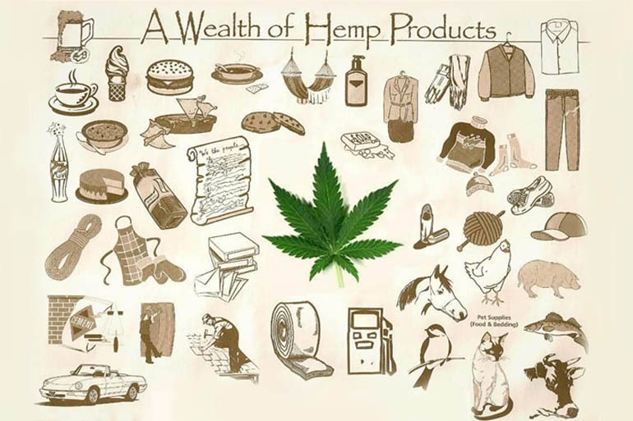
- Improve local resilience and economy.
WHY HEMP:
Marijuana contains high levels of THC, the intoxicating cannabinoid. However, industrial hemp contains less than 0.3 percent of THC. It cannot get the user high in the same way as marijuana. This is one of the primary reasons the United States legalized the growth of hemp among licensed individuals and organizations.

WHAT IS HEMP FABRIC?

Hemp fabric is a type of textile that is made using fibers from the stalks of the Cannabis sativa plant. This plant has been recognized as a source of extraordinarily tensile and durable textile fibers for millennia, but the psychoactive qualities of Cannabis sativa have recently made it harder for farmers to produce this immensely beneficial crop.
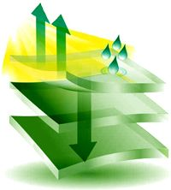
Over thousands of years, Cannabis sativa has been bred for to produce stronger and better fibers and have purposefully reduced the levels of psychoactive cannabinoids produced by their crops. In addition, hemp is a lightweight fabric, which means that it is highly breathable, and it also effectively facilitates the passage of moisture from the skin to the atmosphere, so it is ideal for hot climates. It is easy to dye this type of fabric, and it is highly resistant to mold, mildew, and potentially harmful microbes.
Hemp fabric softens with each washing, and its fibers don't degrade even after dozens of washings. Since it's also relatively easy to produce organic hemp fabric sustainably, this textile is practically ideal for clothing.
The Cannabis sativa plants that have been bred for textile purposes are very low in THC, and they do not generally have pronounced, sticky buds. Once it is processed into fabric, hemp is has a similar texture to cotton, but it also feels somewhat like canvas. Hemp fabric is not susceptible to shrinkage, and it is highly resistant to pilling.
Since fibers from this plant are long and sturdy, hemp fabric is very soft, but it is also highly durable; while a typical cotton T-shirt lasts 10 years at the most, a hemp T-shirt may last double or triple that time. Some estimates suggest that hemp fabric is three times stronger than cotton fabric.
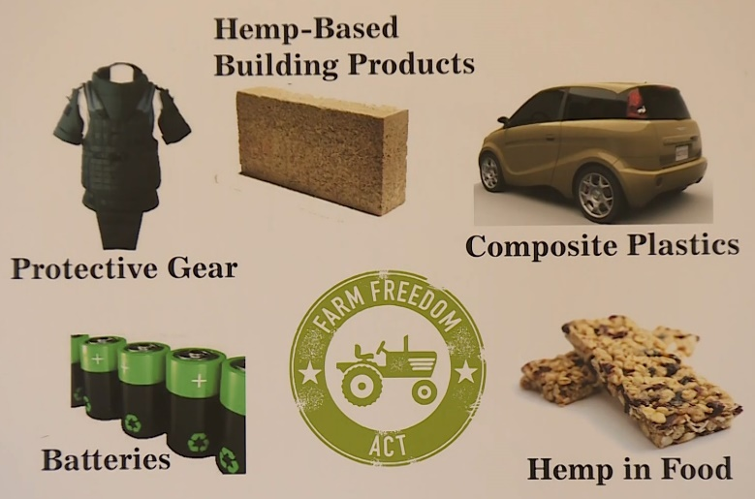
BENEFITS OF HEMP CLOTHING
- It Reduces Carbon Which Helps the Environment
- Less Water Is Used and Wasted
- It Is Better for The Health of The Soil
- Hemp Clothes Are Comfortable to Wear
- Hemp Clothing Comes with Antibacterial Properties

Third an advertising campaign promoting this new industry coming to the location would need to be made. This advertising will also bring many more small companies back to the area, the infrastructure will need to be there to promote the new manufacturers.
These types of infrastructures like food vendors, housing renovations, and other small manufacturers that may produce needed support for the products, hotels, and construction workers who will work on the renovations, etc. will all start to blossom.
Grocery stores and personal support industries who will support the laborers who will now be able to spend their earned income will help to blossom the area.
GREENHOUSES FOR COMMUNITY’S SAFE FOOD SOURCE
Additionally, we plan on putting up Green houses to grow food for the local communities to feed those who cannot afford fresh vegetables and fruit, also to supply our Homeless communities’ year-round food. These will go both on the Property for the Homeless as well as our own Property.
Too many food products currently contain harmful chemicals and fertilizers, and many are GMO modified. Families in communities and farmers everywhere need to be growing more and more of their own chemical free and safe food. There are two growing seasons as the winter in most states is too cold for growing gardens.
We propose to target subdivisions and small communities and install fully equipped greenhouses. We will start with ten greenhouses per county. These greenhouses will be large and will service a whole community or subdivision. It is a way to bring people together to take charge of their health and safe food source. We hope it will lead to fruit orchards and other home-grown healthy alternatives.
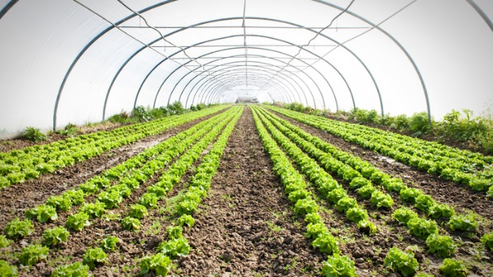
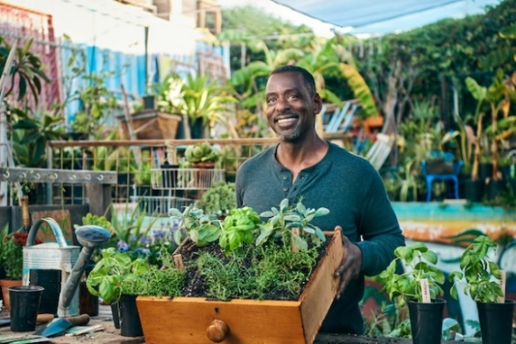
We are looking at 10 greenhouses per county in 628 counties combined in Texas, Oklahoma, Louisiana, Arkansas, New Mexico and Missouri. This project can grow with time. We are looking at 20 years to get these counties serviced, maybe longer. It depends on the greenhouse companies' ability to manufacture and install quickly. There will be teams meeting with the different communities and subdivisions to find out the interest, need, permits needed and permissions needed.

These greenhouses will help enable communities to become food source independent. We hope to renew the project in 20 years to include other states. The project can lead to canning classes, socializing and farmers markets being brought back into communities.
- Cost estimate: based on 32’x54’2 ½" size
- Base cost: $145,410 (before taxes or delivery) some options chosen
- Installation: add 30%
- Cement slab: $8 square foot
- Climate control: $18,000 each (heat and cool)
- Engineering:
- All numbers except the base cost will change based on location and economy. Example, Houston would not need heat part of climate control...it's cheaper for teams to rent motel in Amarillo than it is in Houston...all those factors determine installation prices.
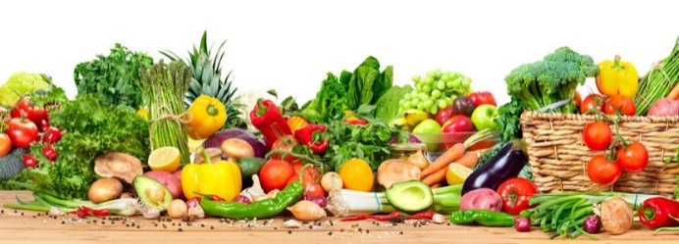
- Costs Listed do not include Land Purchase or Employees at this time until Project Managers Can be Consulted.

GROWING ENVIRONMENTALLY FRIENDLY RENEWABLE USABLE PLANTS
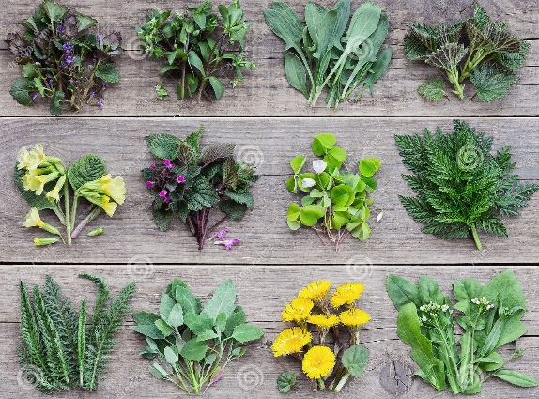
There are not enough renewable environmentally friendly plants being grown across the nation. Not all states have the best weather and facilities to grow multiple plants such as Texas.

We want to set up at least 1000 acres in farmland in the Texas Hill Country. This will require several properties. We plan to install many greenhouses as well as work the land. The weather is amenable and the soil types are friendly.

These areas are perfect for growing lavender, bamboo, jujubes and hemp. Each of the plants have multiple uses and can be sold with funds after expenses being put back into the trust account. These farms will supply multiple jobs to many people and provide usable renewable products for the public.

PROJECT: Growing Environmentally Friends Renewable Usable Plants

Growing these plants involves the environment. Our world needs environmentally friendly natural plants. There are many such plants that can be grown that are beneficial to animals, humans and the earth. Three of those plants are lavender, bamboo, jujubes and hemp. These plants have medicinal properties and uses as well as contributing clean air. There are many other uses for each of them. We want to grow them all.

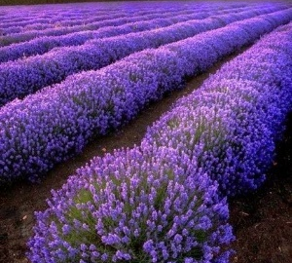
PLANT 1: Lavender is an environmental asset to any area providing both beauty and multiple uses. The plants are hardy and have high yield per acre. The oil from lavender is soothing and aromatic and is a natural antiseptic. The essential oils heal burns, cuts and infections and relieves stress. Many products can be made from lavender providing products for the public as well as limited amount of jobs. Lavender will attract bees. Those bees are important for the balance of nature and to have good crops of fruits, vegetables and flowers.
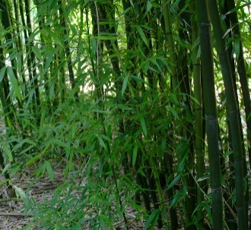
PLANT 2: Profiting with bamboo is a slow starting project but the rewards are great. Bamboo is not only a hugely popular landscape plant but there are many other uses as well. Some of those are vases, fences, privacy screens and parrot stands. Bamboo can be used for food, medicine, musical Instruments, fabrics, paper pulp, basketry and more. Bamboo can be grown side by side to hemp.

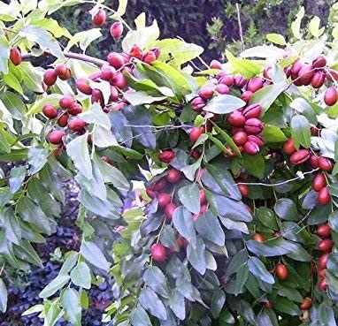
PLANT 3: Jujubes aka Chinese Dates are very easy to grow, drought resistant and almost all parts of the plants have medicinal properties. The number of health benefits of jujubes is massive. A person can get 18 of the 24 essential amino acids from these tasty fruits. These plants are easy to grow and like lavender the bees love the tiny tree flowers. Animals love to eat these fruits as well.

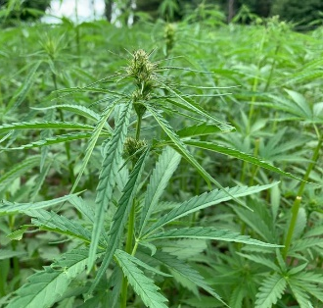
PLANT 4: Growing Hemp will help heal the world and humankind. Hemp is one of the world’s oldest crops. It also happens to be one of the most versatile. Humankind have been cultivating hemp for thousands of years. From plastic to paper, the hemp plant provides a way to live in harmony with the environment and the ecosystems that support it.

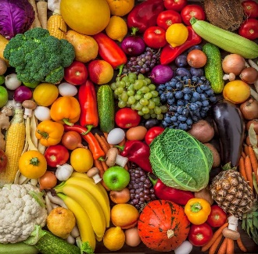
Hemp has the potential to leave a cleaner and greener planet for future generations. Hemp as a complete protein provides our bodies with fuel, much needed for energy. Hemp protein can help you get the nutrients you need while repairing muscles and reducing inflammation. Hemp can be grown side by side bamboo.

PLANT 5: Growing fruits and vegetables will help all communities. We will plant orchards where we can and rows of vegetables for public to pick at will. We will also construct large greenhouse.

This project is unique to the central Texas and Hill Country. The farmland can spread out from Erath county to Llano and Burnet counties. It will require farmers and other laborers. On the same properties can also be grown fruit orchards and garden vegetables. Many of these vegetables and fruits will be donated to food banks and to those who have no access to a place to grow gardens.

We estimate costs to be around $50,000,000 first time purchase and expenses and additional $1,000,000 maintenance, labor and upkeep for 50 years. We would put $50,000,000 into interest bearing account and use the interest for operational and expenses.

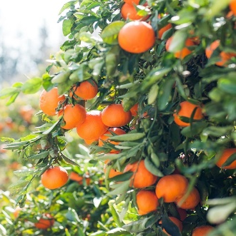
7. PROJECT: PROVIDING ORGANIC EGGS, FRUITS AND VEGETABLES

The trust can purchase many farms in many states and set up farmers to supply organically grown eggs and vegetables and add orchards with fruit trees. Each farm will be set up with 50 to 100 acres farm complete with several chicken houses for organic eggs and several greenhouses for chemical free vegetables year round.

The orchards will vary according to the fruit for each area. The farm will also have acres to plant large amounts of garden items. The trust will furnish everything needed to grow these items then buy them back from the supplier. This method will insure availability of organically grown eggs, vegetables and fruits. It will also inspire the person/persons in charge to continue to do an excellent job so that they will be paid well when trust buys items back.

The organically grown items can then be distributed across multiple states. This will insure the good healthy foods for many people at a very small price or free in areas that need them.

We estimate costs for the 1000 acres farms to be around $50,000,000 first time purchase and expenses and additional $1,000,000 maintenance, labor and upkeep for 100 years. This will be multi-generational.

All Projects as outlined WILL BE A MULTI-GENERATIONAL PROJECTS With employing a great deal of local help, providing a needed service, and responsible service to children, adults and the elderly FOR Many Generations To Come.
RFERENCES:

https://wayofleaf.com/hemp/is-hemp-the-perfect-permaculture-crop
https://www.google.com.au/amp/s/stuffstonerslike.com/can-we-call-hemp-a-perfect-permaculture-crop-everything-you-need-to-know/amp/
https://www.redbubble.com/i/sticker/Earth-Warrior-by-Crushonnature/55932613.EJUG5?utm_source=google&utm_medium=cpc&utm_campaign=g.pla+notset&country_code=AU
https://www.teepublic.com/poster-and-art/5077953-earth-warrior?feed_sku=5077953D6V

