"I Can't Keep Watching Patients Die Needlessly!" Medical Professor Test... https://healthimpactnews.com/2020/i-cant-keep-watching-patients-die-ne...
- Health Impact News - https://healthimpactnews.com -
“I Can’t Keep Watching Patients Die Needlessly!” MedicalProfessor Testifies to Congress that COVID Cure AlreadyExists with Ivermectin
Posted By Brian-Admin On December 9, 2020 @ 4:42 pm In Headline,Medicine Watch | 7Comments
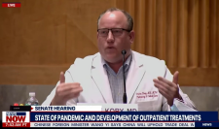
1 of 9 1/23/2021, 11:32 PM
"I Can't Keep Watching Patients Die Needlessly!" Medical Professor Test... https://healthimpactnews.com/2020/i-cant-keep-watching-patients-die-ne...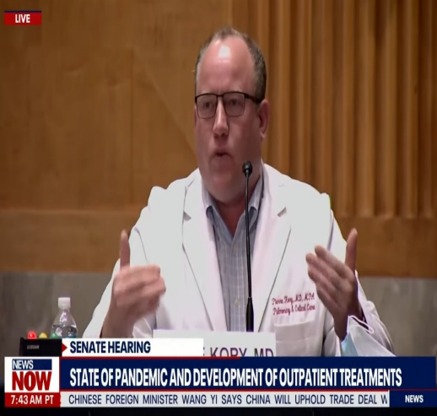
by Brian Shilhavy
Editor, Health Impact News
Dr. Pierre Kory M.D., a pulmonary and critical care specialist who is also an Associate Professor ofMedicine at St. Luke’s Aurora Medical Center in Milwaukee, Wisconsin, pleaded with members ofCongress to have the NIH, CDC, and FDA look at the “mountains” of data that he and hiscolleagues have gathered on the drug Ivermectin, which is already approved by the FDA as ananti-parasitic drug, and their success in treating COVID patients.
He states: “If you take it, you will not get sick.”
Dr. Kory is president of the Frontline COVID-19 Critical Care Alliance (FLCCC) ^{[1]}, and their
2 of 9 1/23/2021, 11:32 PM
"I Can't Keep Watching Patients Die Needlessly!" Medical Professor Test... https://healthimpactnews.com/2020/i-cant-keep-watching-patients-die-ne...
success in treating patients with COVID has been so dramatic, that he referred to it as a “miracledrug.”
From the organization’s website ^{[1]}:
Appearing as a witness Tuesday morning before the Senate Committee on Homeland Securityand Governmental Affairs—which held a hearing on “Early Outpatient Treatment: An EssentialPart of a COVID-19 Solution”— Dr. Pierre Kory, President of the Frontline COVID-19 Critical CareAlliance (FLCCC), called for the government to swiftly review the already expansive and stillrapidly emerging medical evidence on Ivermectin.
The data shows the ability of the drug Ivermectin to prevent COVID-19, to keep those with earlysymptoms from progressing to the hyper-inflammatory phase of the disease, and even to helpcritically ill patients recover.
Dr. Kory testified that Ivermectin is effectively a “miracle drug” against COVID-19 and calledupon the government’s medical authorities—the NIH, CDC, and FDA—to urgently review thelatest data and then issue guidelines for physicians, nurse-practitioners, and physician assistantsto prescribe Ivermectin for COVID-19.
The Frontline COVID-19 Critical Care Alliance (FLCCC) ^{[2]} is comprised of some of the mosthighly published scientists in the world, with over 2000 peer-reviewed publications among them.Dr. Kory states:
I am severely troubled that the NIH, FDA, and CDC – I do not know of any task force that wasassigned or compiled to review repurposed drugs in an attempt to treat this disease.
Everything has been about novel, and or expensive pharmaceutically engineered drugs (likeremdesivir and vaccines.)
We have a hundred years of medicine development. We are experts in all of the medicines weuse, and I do not know of a task force that has focused on repurposed drugs.
We have filled that void. That is all we have done, focus on the things we know and the things wedo.
We have a solution to this crisis. There is a drug that is proving to be of miraculous impact.
And when I say “miracle,” I do not use that term lightly. And I don’t want to be sensationalizedwhen I say that. That is a scientific recommendation based on MOUNTAINS of data that hasemerged in the last 3 months.
Dr. Kory explains that the NIH recommendation NOT to use Ivermectin for COVID outside ofclinical trials, was from August 27th, and that 3-4 months later, “mountains” of data have
3 of 9 1/23/2021, 11:32 PM
"I Can't Keep Watching Patients Die Needlessly!" Medical Professor Test... https://healthimpactnews.com/2020/i-cant-keep-watching-patients-die-ne...
emerged from countries around the world showing the “miraculous” effectiveness of Ivermectin.It basically obliterates transmission of this virus. If you take it, you will not get sick.
The most emotional part of Dr. Kory’s testimony was when he described what he was seeing inpatients in the ICU.
I’m a lung specialist. I’m an ICU specialist.
I’ve cared for more dying COVID patients than anyone can imagine. They’re dying because theycannot breathe.
I watch them every day. They die. By the time they get to me in the ICU, they are already dying.They’re almost impossible to recover.
Early treatment is key. We need to offload the hospitals.
We are tired. I can’t keep doing this.
If you look at my manuscript, and if I have to go back to work next week, any further deaths aregoing to be needless deaths.
And I cannot be traumatized by that. I cannot keep caring for patients when I know that theycould have been saved with earlier treatment.
And that drug that will treat them and prevent the hospitalization is Ivermectin.
Watch the full testimony. This is on YouTube, but if it disappears, we have a copy on our Bitchutechannel ^{[3]} as well.
4 of 9 1/23/2021, 11:32 PM
"I Can't Keep Watching Patients Die Needlessly!" Medical Professor Test... https://healthimpactnews.com/2020/i-cant-keep-watching-patients-die-ne...

The U.S. Government and Big Pharma Are Guilty of MassMurder!
5 of 9 1/23/2021, 11:32 PM
"I Can't Keep Watching Patients Die Needlessly!" Medical Professor Test... https://healthimpactnews.com/2020/i-cant-keep-watching-patients-die-ne...
This is now the second group of physicians who treat COVID patients that have presented theirevidence and experience in treating and healing COVID patients with a near 100% success ratewith older drugs that have already been approved by the FDA to the politicians sitting inWashington D.C.
The first group was the group called “Frontline Doctors” who presented their evidence forhydroxychloroquine, and their nearly 100% success rate in treating patients and not having tosend them to the hospitals.
Learn more about the Frontline Doctors and the hydroxychloroquine scandal here^{[4]}.
The U.S. Government is clearly guilty of mass murder! The two main bureaucrat doctorsresponsible for the deaths of tens of thousands if not hundreds of thousands of American livesare FDA Director Stephen Hahn and NIAID Director Anthony Fauci.
These two men and others who serve with them have pushed to get new drugs to marketinstead, and now are poised to unleash a dangerous, fast-tracked COVID vaccine never beforeseen in the human population.
And the ONLY way they could approve these new drugs and vaccines, was to LIE about effectivecures that already exist, which means all of these new drugs and vaccines developed for COVIDare ILLEGAL!
Let’s not beat around the bush and let’s call this what it really is: Crimes Against Humanity!
Both of these men, and many others, need to be arrested for mass murder, tried in a court of lawwith a jury of their peers, and then executed by sentence of DEATH!
And for those of you still supporting President Donald Trump, who not only is allowing this tohappen but encouraging it by rushing dangerous vaccines to market at “Warp Speed” whennobody needs these vaccines, how can you keep looking the other way when thousands of peopleare dying needlessly??
See Also:
Doctors Around the World Issue Dire WARNING: DO NOTGET THE COVID VACCINE!! ^{[5]}
Having problems receiving our newsletters? See:
How to Beat Internet Censorship and Create Your OwnNewsfeed ^{[6]}
6 of 9 1/23/2021, 11:32 PM
"I Can't Keep Watching Patients Die Needlessly!" Medical Professor Test... https://healthimpactnews.com/2020/i-cant-keep-watching-patients-die-ne...[7] We Are Now on Minds.com^{[8]}, MeWe ^{[9]}, Gab^{[10]}, and Parler ^{[11]} (currently down)!
If our website is seized and shut down, find us on Minds.com^{[8]}, MeWe^{[9]}, Gab^{[10]}, and Parler^{[11]} for further instructions about where to find us.
[12]
Is God’s Judgment About to Fall on America? What is the“Mark of the Beast”? ^{[12]}
[13]
7 of 9 1/23/2021, 11:32 PM
"I Can't Keep Watching Patients Die Needlessly!" Medical Professor Test... https://healthimpactnews.com/2020/i-cant-keep-watching-patients-die-ne...
Unmasking Who is Behind the Plandemic and Rioting toUsher in the New World Order ^{[13]}
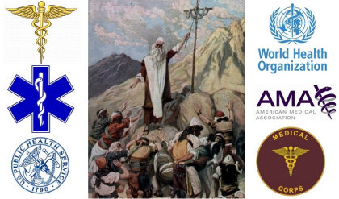[14]
The Satanic Roots to Modern Medicine – The Mark of theBeast? ^{[14]}
Article printed from Health Impact News: https://healthimpactnews.com
URL to article: https://healthimpactnews.com/2020/i-cant-keep-watching-patients-die needlessly-medical-professor-testifies-to-congress-that-covid-cure-already-exists with-ivermectin/
URLs in this post:
[1] Frontline COVID-19 Critical Care Alliance (FLCCC): https://covid19criticalcare.com[2] The Frontline COVID-19 Critical Care Alliance (FLCCC): https://covid19criticalcare.com/[3] Bitchute channel: https://www.bitchute.com/channel/HealthImpactNews/
[4] Frontline Doctors and the hydroxychloroquine scandal here: https://healthimpactnews.com/covid-hydroxychloroquine-scandal/
[5] Doctors Around the World Issue Dire WARNING: DO NOT GET THE COVID VACCINE!!:https://healthimpactnews.com/2020/doctors-around-the-world-issue-dire-warning do-not-get-the-covid-vaccine/
[6] How to Beat Internet Censorship and Create Your Own Newsfeed: https://healthimpactnews.com/2020/how-to-beat-internet-censorship-and-create your-own-newsfeed/
[7] Image: https://healthimpactnews.com/covid-information-center/
[8] Minds.com: https://www.minds.com/healthimpactnews/
[9] MeWe: https://mewe.com/i/healthimpactnews [10] Gab: https://gab.com/HealthImpactNews [11] Parler: https://parler.com/profile/HealthImpactNews/posts
[12] Image: https://created4health.org/is-gods-judgment-about-to-fall-on-america-8 of 9 1/23/2021, 11:32 PM
"I Can't Keep Watching Patients Die Needlessly!" Medical Professor Test... https://healthimpactnews.com/2020/i-cant-keep-watching-patients-die-ne...
what-is-the-mark-of-the-beast/
[13] Image: https://created4health.org/unmasking-who-is-behind-the-plandemic-and rioting-to-usher-in-the-new-world-order/ [14] Image: https://created4health.org/the-satanic-roots-to-modern-medicine-the mark-of-the-beast/
Copyright © 2020 Sophia Media Network. All rights reserved.
9 of 9 1/23/2021, 11:32 PM

