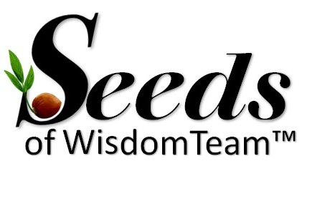
Your Community
We are SEEDS OF WISDOM TEAM™
UNITED in LOVE to HELP YOU, our members.
THANK YOU TO OUR SEEDS OF WISDOM TEAM™ LEADERS
supporting each other and our mission. LINK
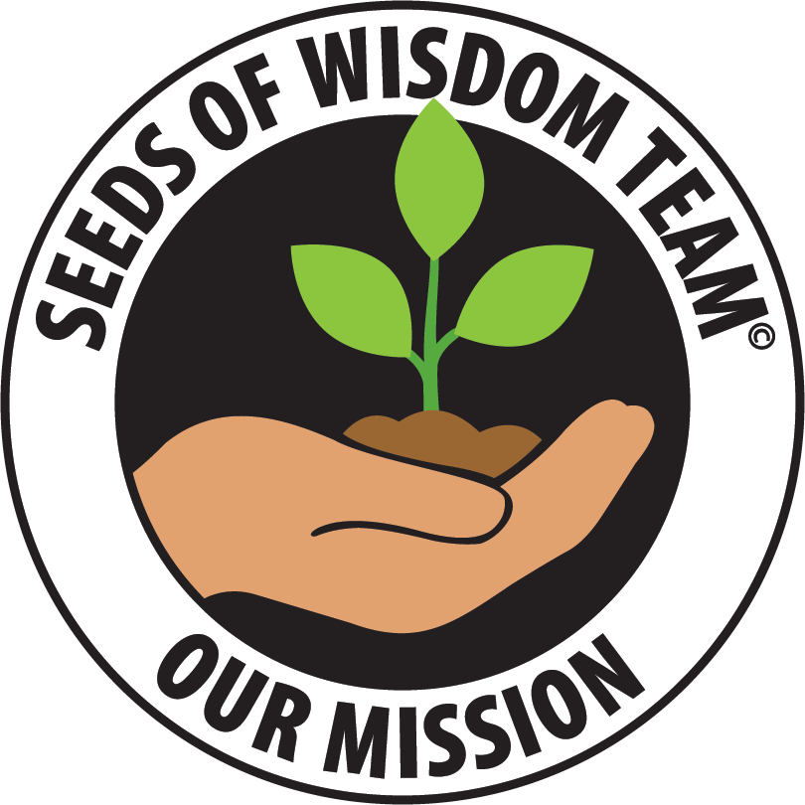
Seeds of Wisdom Team Mission

will encourage and facilitate educational materials for you and others to achieve generational
growth and wealth for you and your family.
True generational wealth is found in the Kingdom of Jesus.
John 3:16 -17
We are helping people NOW

WE ARE GOD'S PEOPLE IN HIS COMMUNITY PLANTING GODS' SEEDS OF WISDOM

Seeds Of Wisdom: SOWing Good Seeds
WE ARE GOD'S PEOPLE IN HIS COMMUNITY PLANTING GODS' SEEDS OF WISDOM
Seeds Of Wisdom:
SOWing Good Seed
But the seed on good soil stands for those with a noble and good heart, who hear the word, retain it, and by persevering produce a crop.
Luke 8:15

Messages will be put on the website
RECOMMEND TO READ AND JOIN:

HOW TO USE TELEGRAM LINK

Telegram Room LINK

HIDE YOUR NAME AND NUMBER.
Block others or report if needed.

For your security, it may not be wise to use your real name and photo on your avatar. Be aware of sending and receiving private messages.

We use the Computer, Security Scam Room LINK along with the website to keep people informed.

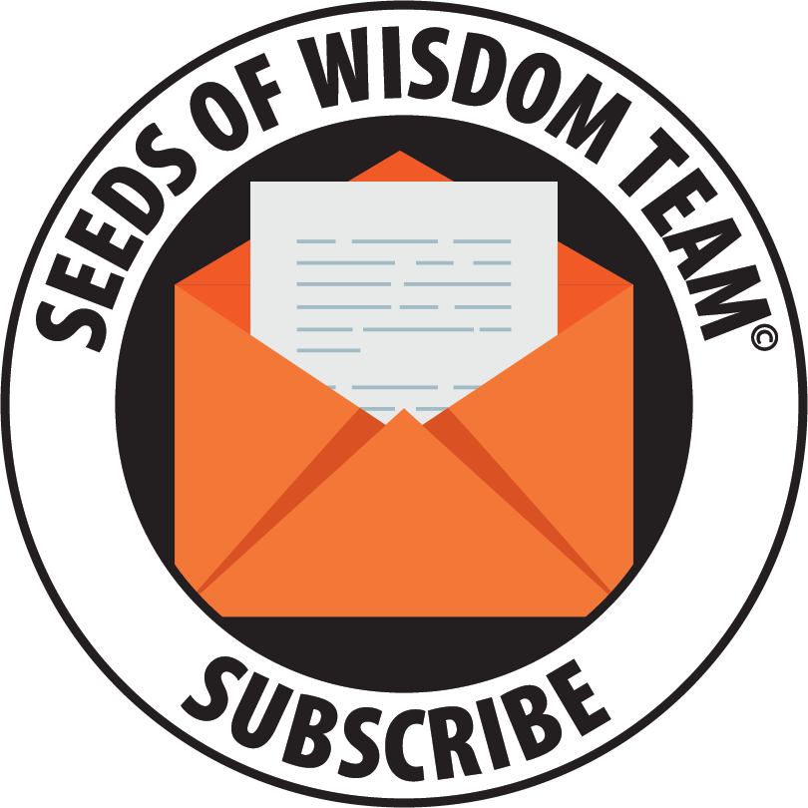

The website is where we will be posting and sending

our emails to the ones who have subscribed.

Join the Community - Get Involved!

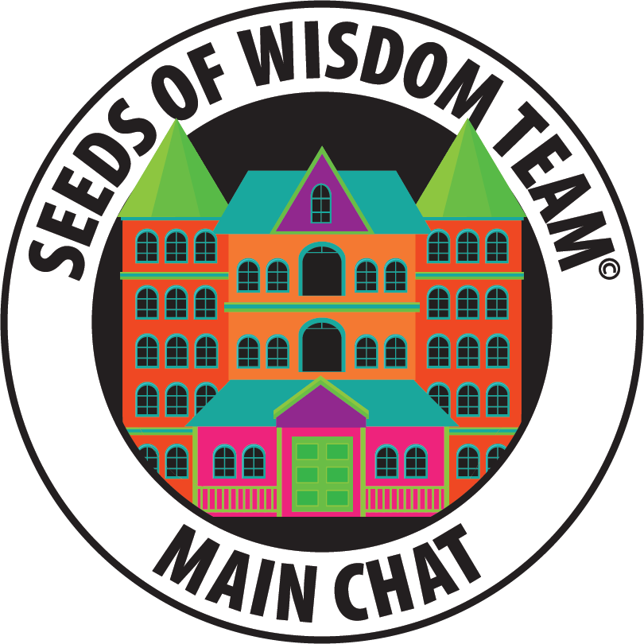

Website Rooms Avatar & Telegram Rooms Avatar
Trouble Joining Rooms? Meet Rose who keeps our rooms clean. To help keep you safe, you’ll be asked to agree with our standards by filling out info for a Captcha Rose will ask you to fill out. If you don’t fill it out you will be asked till you do. Just fill in the info asked for and you are in. Don’t forget to click JOIN at the bottom of the page after the Rose quiz.

Click on the house avatar on the website for information.

We do not post links to other rooms.

because we cannot answer for them.
Please do your own research.

Rooms Directory on Telegram:

https://t.me/+0avIxH7QOtUwMWZh

Website Rooms:
(Click avatars to join)

https://www.seedsofwisdomteam.com/rooms

Welcome doc with docs listed:

(Also pinned in the Living Room)

https://www.seedsofwisdomteam.com/welcome-info

Website:
https://www.seedsofwisdomteam.com/

Subscribe:
https://www.seedsofwisdomteam.com/subscribe

Customer Service on Telegram:
@CustomerServiceSeedsofwisdomteam

Announcement:

Announcement room on telegram: LINK

Where we will send out important messages in Telegram from the channel
Seeds of Wisdom Channel Link

Standards & Rules:

https://www.seedsofwisdomteam.com/standards

WE ARE A COMMUNITY OF PRIVATE ROOMS. YOU WERE INVITED TO JOIN US. AS OUR GUEST, WE EXPECT YOU TO RESPECT OUR STANDARDS AND FOLLOW OUR RULES.

Disclaimer:

https://www.seedsofwisdomteam.com/disclaimer

One of the Seeds of Wisdom Team’s goals is to keep you grounded and grow in good soil.

Living Room | https://t.me/joinchat/SjBcmR__Z4Q3VUpB
Rooms Directory  Read only | https://t.me/+0avIxH7QOtUwMWZh
Website Directory  Read only | https://t.me/+luaVTZo81-ZmYmIx
Planning Room  Resources to help you plan.  for your exchange | https://t.me/+Uh9VB4bXUQhkO_Dw
Texas Snake Community | https://t.me/joinchat/VAm-AlWWqWPzyK8G
Isaac’s Room  Read only | https://t.me/joinchat/Tc5mohvokA3F-CnM
Okie Chief Pilot | https://t.me/joinchat/TtKVJ1fhy7VEskjn
Bob Lock  Common Law TRUSTs | https://t.me/joinchat/JrH1jkseabV4JwXm0OwgMw
Gipper’s News Reader  Read only | https://t.me/joinchat/JrH1jhR6uiXQH6rs0cVN3w
Goldilocks©  Read only | https://t.me/+YU9UrHLxFbszOTJh
Goldilocks© Highlights  Read only | https://t.me/+E1dAKSJXgpIzOWIx
Truth Tellers Hot Topics  Channel | https://t.me/+RduH1iXS4yhhYWNh
Q & A Docs Room  Read only | https://t.me/+OtOMp3Ijm2ZhNTgx
Q & A Room | https://t.me/+CuARN1065OwwNDEx
Jester’s Intel Hub  Read only | https://t.me/+56NFfTYCsdwxZWQx
Start Here and Currency Info | https://t.me/+hrGNCcQUMs43ZWRh
Back to Basics * | https://t.me/+q3K05zjcJS1lYmUx
Lawman Lounge | https://t.me/+Q5iZWsC_Ggw4ZTQx
Prayers and Encouragement | https://t.me/joinchat/VAEt8hWN23 xADFDW
Computers, Security Scams | https://t.me/+BW3CMOoG-o9hODFh
Saturday Night Live Calls Channel | https://t.me/+aLmTAeuTKJYzNGI5
Saturday Night Live  Q & A | https://t.me/+cF2rvPf0jq83ZmVh
Team Call (Channel) | https://t.me/+mSL7IFpdXCM3NGUx
Team Q & A | https://t.me/+TESefeLIf1k2ZTJh
Archived Live Calls  Read only | https://t.me/joinchat/YHWQUW4ZaOsxMzVh
Debt clock photos  Read only | https://t.me/+-qbX72Niq1RkNzYx
SAVE OUR CHILDREN ROOM | https://t.me/+8op9B1lECyRjZjQ5 ❤️
Resources for Help | https://t.me/+Rh8YNuC2xgov31Gk
Positive Posts  Read only | https://t.me/joinchat/O4P0rosbINIxNDFh
Wisdom of the Old Guys  Read only | https://t.me/+yU3WzssrMz9jZjJh
Pets | https://t.me/joinchat/JrH1jleUUp_0HFi_2EFLYw
Cafe | https://t.me/+WJ98lPRJwAQjFzrh
Cars & Aviation | https://t.me/joinchat/JrH1jlc2-f12DHVbl--P9w
Padded Room | https://t.me/joinchat/JrH1jhIChS6VZBwik8Z3HA
Cowboy Down Under /  Ziggy's Playground | https://t.me/joinchat/Q0RZ8epq7IR3u1GS
Native American  Indian Development  Not needed | https://t.me/joinchat/SiiViBKec80CW34a
Music | https://t.me/joinchat/JrH1jk83BLVlFUKeit-7Fg
Snake and the Gang  Jukebox  Read only | https://t.me/joinchat/JrH1jkp2iCrhe8CGWF_amg
Thank You Room  Read only | https://t.me/+bDh_8xU7UWY2OGNh
Dollar Day Stories  Read only | https://t.me/+7HjsRWZZUew5NDNh
SOWT Merch /Store | https://t.me/+ctzXRRd23MtlZTQx

Professional & VIP Team Bio’s with audio:
Professional & VIP INFO LINK

How to download Calls and Docs LINK
Your info  Navigation Guide  CLICK on the links for more info | EDUCATION AND WEB LINKS  Recordings found here https://www.seedsofwisdomteam.com/recordings  For a small donation, the education links donations to help others in need of a hand up. Thank You
Texas Snake Room Link  NEW Texas Snake -Docs Room Link Read only  Texas Snake -Docs Link | Texas Snake’s Recordings  https://www.seedsofwisdomteam.com  Rooms  https://www.seedsofwisdomteam.com/rooms
Bob Lock Common Law  Bob Lock Audio Bio Click here  Bob Lock Room link | Bob Lock - Recordings found under the store and recordings.  https://www.seedsofwisdomteam.com/  NEW Bob Lock Docs link  Bob Lock Docs link
Goldilocks  Goldilocks | Goldilocks Bio
Canary Girl  Canary Girl Bio Link | Tips by Canary Girl

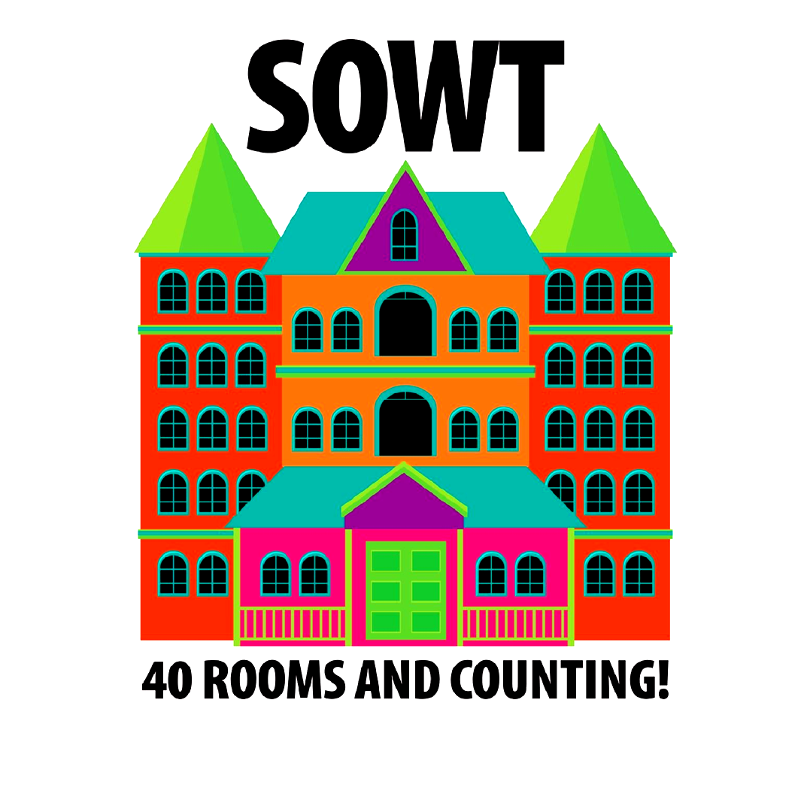
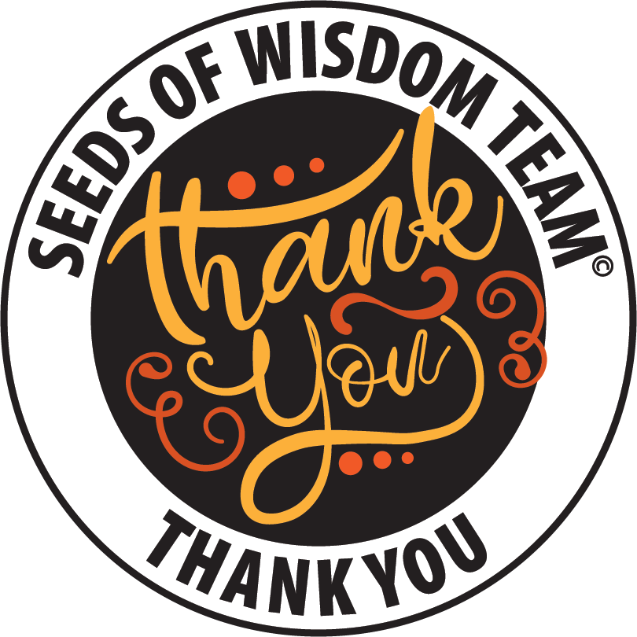

Everyone plays a key role and builds a community!

Thank you for being a part of our community!

Encouraging others to grow,

Salty Toes & the Seeds of Wisdom Team

FOR EDUCATIONAL AND INFORMATIONAL PURPOSES ONLY

The information contained on this Website and the resources available for download through this website and telegram are for educational and informational purposes only.
NOT TO BE SOLD. NOT PROFESSIONAL ADVICE. NOT FINANCIAL ADVICE. NOT LEGAL ADVICE. DO YOUR OWN RESEARCH.
DISCLAIMER LINK. STANDARDS LINK

© 2021-2024 Seeds of Wisdom. All rights reserved. Website Created by SOWT

