23 Lottery Winners Who Lost Millions
ANDREW LISA
January 17, 2023, 12:02 PM

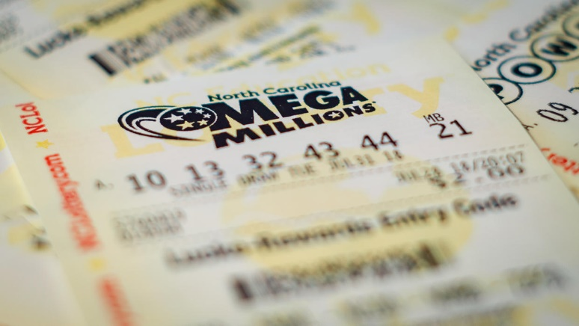
The odds of winning the Mega Millions or Powerball are slim — but the odds of your life devolving into chaos if you somehow pull it off are actually quite good.
Most lottery dreams share a few common themes: yachts and lobster tails, big tips, fast cars, the fast life and a mansion for mom. In reality, instant entry to the nouveau riche class has a way of wrecking friendships, destroying marriages, ending in bankruptcy or worse.
Winning the lottery might seem like a dream come true, but mountains of unearned money are irresistible to greedy and resentful friends and relatives, con artists and charity cases, who scurry out of the woodwork to grab as much of it as they can. In other cases, it's the lottery winners themselves who can't get out of their own way — reckless spending, giving, partying and gambling leave some worse off than they started.

Bob Bird/AP
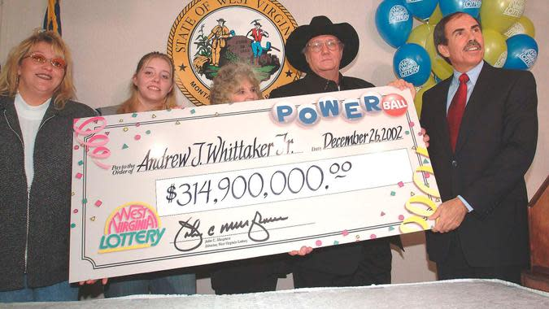
Jack Whittaker
In 2002, Jack Whittaker won a $314 million Powerball jackpot which, at the time, was the biggest lottery prize in history. The West Virginia construction worker, known for his outsized cowboy hats and even bigger personality, remains one of the most extreme cautionary tales about the lottery's power to ruin lives. Whittaker reveled in the ability to give handouts, which he did until the money ran out, donating stacks of cash to churches, diner waitresses, family members, strangers and his local strip club. His life turned to turmoil, according to ABC News. His wife left, his house burned down, he ran afoul of the law, he lost a daughter to cancer and a granddaughter to drugs. In 2020, Whitaker died at the age of 72.

Ken McKay / Shutterstock.com
Lara and Roger Griffiths
Lara and Roger Griffiths' marriage ended in divorce less than a decade after the British couple won a $2.19 million jackpot. Roger chased his rock star dreams and spent big bucks for his band to release an album. Lara got a taste for the high life as the couple paid for exotic cars, an expensive house, designer clothes and accessories, and a pricey private school for their daughter. They dumped hundreds of thousands of dollars into opening a salon, where Lara later worked as an employee to make ends meet. In the end, the couple was left with less than $10.

Tony Gutierrez/AP
David Lee Edwards
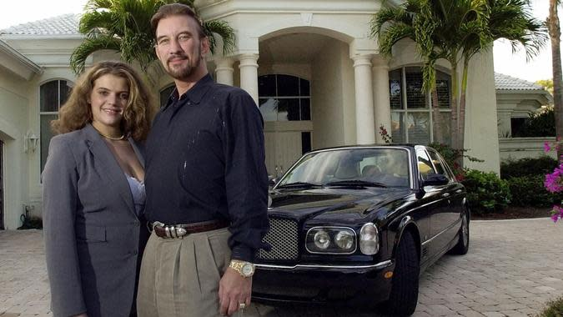
Five years after Kentucky resident David Lee Edwards won a $27 million jackpot, he was penniless and living in a storage shed with his wife. The couple squandered their fortune on the typical goodies that sink so many lucky winners. They bought dozens of high-end cars, mansions and a plane. They blew through $3 million in the first three months. By the end of the first year, $12 million was in the wind. By 2006, the couple had spiraled into drug addiction, and just 12 years after the win changed the course of his life, David Lee Edwards died alone and broke in hospice care at the age of 58.

Geoff Robinson / Shutterstock.com
Mickey Carroll
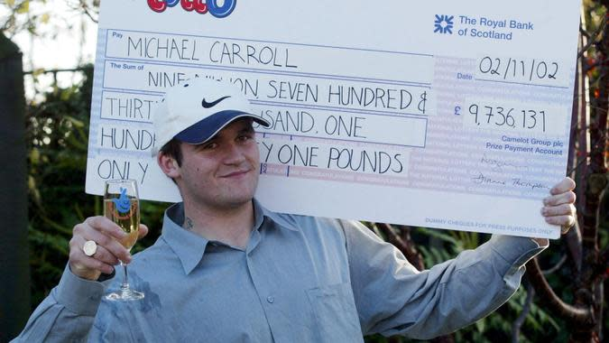
Mickey Carroll was only 19 when he won a British jackpot that sent him into early adulthood with the equivalent of $11.8 million. The media dubbed him the "Lotto Lout" as the young winner tore through his newfound fortune with astonishing speed. Much of it went to drug-fueled partying, with the rest wasted on jewelry, cars and other materialistic excesses. In 2016, he was earning a few hundred dollars a week working in a slaughterhouse. In 2021, he remarried his ex-wife, who left him for cheating with prostitutes during his high-rolling heyday, according to the Mirror.
Bruce Adams/Daily Mail
Callie Rogers
Callie Rogers was another lucky Brit who cashed in big at a very young age, but she was even greener and less prepared to manage her money than Mickey Carroll. When Rogers won the equivalent of $2.3 million in 2003, she was only 16 years old. A decade later in 2013, she had only around $2,500 left in the bank. She torched through the winnings due to drugs — Rogers dropped about $300,000 on cocaine alone — as well as plastic surgery, high-end clothing, gifts and partying. Britain's youngest lottery winner was later banned from driving after crashing her 4x4 during a police chase while she was high on drugs. In 2021, the Daily Mail Reported that Rogers was penniless and living on government benefits at the age of 33, 18 years after striking it rich.

Carlos Rene Perez/AP
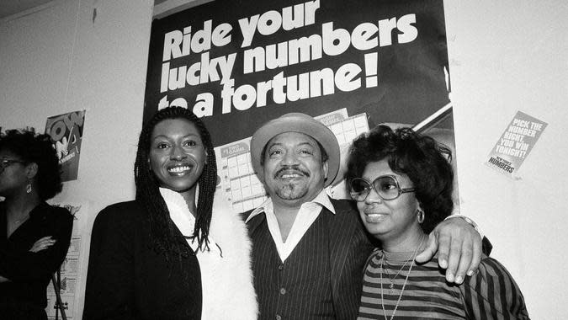
Curtis Sharp
Curtis Sharp won $5 million playing the lottery in New York in 1982. Unfortunately, his story went from rags to riches and back to rags. Sharp's fortune would disappear too quickly due to multiple failed marriages gobbling up much of his newfound wealth, as did visits to the casino and reckless spending and giving.

Shutterstock.com
Evelyn Adams
Evelyn Adams made lottery history when she won two multimillion-dollar New Jersey prizes, in 1985 and 1986. Her total haul was $5.4 million. Like so many other lucky winners, however, Adams couldn't get out of her own way. She gambled much of the money away, gave too many gifts to family members, spent too much and made bad investments. According to Forbes, Adams blew it all and moved into a trailer.

Shutterstock.com
William Post
William "Bud" Post was broke when he died in 2006, despite winning $16.2 million in the Pennsylvania Lottery in 1988. It didn't last long. Just one year after he hit it big, Post was $1 million in debt. His ex-girlfriend sued him for part of his winnings and his brother reportedly hired a hitman to kill him, according to Forbes. The real problem, however, was his lavish spending. He bought houses, boats, cars and a twin-engine plane that he wasn't even licensed to fly.

amstockphoto / Getty Images/iStockphoto
Lisa Arcand
Massachusetts resident Lisa Arcand won a cool $1 million when she hit the lottery in 2004. It was all gone in less than four years. Arcand bought a furnished house and several vacations, but the biggest hit came in the form of a failed investment. Arcand opened a restaurant in her hometown of Lawrence, which she was forced to close within a few years.

Willowpix / Getty Images
Alex Toth
Alex Toth died broke in 2008 at the age of 60. He checked into a mental institution after splitting with his wife and getting charged with tax fraud by the IRS. All of this happened after the Florida resident won $13 million in the lottery. He chose to receive his winnings in annual installments, which were paid in the ominous amount of $666,666 each. He squandered it all on an excessive lifestyle.

mixetto / Getty Images
Gerald Muswagon
Canadian Gerald Muswagon bought a $2 lotto ticket that made him an instant millionaire in 2011. He won a $10 million jackpot but blew through it in just a few short years. He bought a house that doubled as a nightly party spot hosting his ever-growing legion of hangers-on. He also blew the cash on cars, partying and gifts, while racking up a string of legal entanglements, according to The Globe and Mail. By the end, he was doing manual labor on a farm to support his girlfriend and six young children. Seven years after his big win, he hanged himself in his parents' garage.

Shutterstock.com
Janite Lee
South Korean immigrant Janite Lee was working at a wig shop when she won $18 million in the Illinois lottery in 1993. Eight years later, when she filed for bankruptcy, she had less than $700 in the bank and $2.5 million in debt. Her donations were well-intentioned, but she simply gave too much. After donating huge sums to educational, political and social causes, she sold her rights to future annual payments in exchange for a lump sum, according to Time. But even that wasn't enough to keep her out of bankruptcy court.

Shutterstock.com
Marva Wilson
Swindlers, grifters and con artists see lottery winners as prey, a fact few people know better than Marva Wilson. The great-grandmother won $2 million in the Missouri lottery in 2008 and quickly became the target of a scammer named Freya Pearson. Pearson smooth-talked her way into Wilson's life — and bank accounts. Under the guise of helping her file a lien, handling her taxes and establishing a nonprofit in her name, Pearson stole and spent all of Wilson's winnings. Pearson was eventually sentenced to five years in prison.

Shutterstock.com
Willie Hurt
Willie Hurt won a $3.1 million Michigan Super Lotto jackpot in 1989. This was during the height of the crack epidemic, and Hurt was deeply tangled in the mayhem. His winnings became fuel for a raging rock cocaine addiction. By 1991, he was broke and going through a divorce. He was also charged with murdering a woman while on a multiday drug and alcohol bender, the Associated Press reported.

Shutterstock.com
Ibi Roncaioli
One of the more bizarre and tragic stories of lost lottery fortune is the tale of Ibi Roncaioli, a Canadian woman who won a $5 million lottery jackpot in 1991 and died in 2003. Five years later, her husband, Dr. Joseph Roncaioli was convicted of poisoning her. Ibi Roncaioli had squandered not only the lottery fortune but also the hefty salary her gynecologist husband earned. Authorities believe that the doctor hatched his plans when he discovered his wife's double life, which authorities allege included alcoholism and reckless gambling, the Toronto Star reported.

jarun011 / Getty Images/iStockphoto
Urooj Khan
Ibi Roncaioli isn't the only lotto winner whose life ended with a lethal dose of poison. Chicago businessman Urooj Khan died suddenly at the age of 46 just a few weeks after he won $1 million in 2012 — he hadn't even received the money yet, the Chicago Tribune reported. His death was attributed to natural causes at first, but at the prodding of his family, a new test revealed he'd been poisoned to death with cyanide. As of 2021, his case remained unsolved.

gorodenkoff / Getty Images/iStockphoto
Suzanne Mullins
Suzanne Mullins won a $4.3 million Virginia lottery jackpot in 1993, which she agreed to split three ways with her husband and daughter. Strung out over 20 years, however, her share of the annual installments were less than $50,000 each. After paying for an uninsured relative's lengthy illness, she was forced to borrow money with her future payments as collateral and went deep into debt. Mullins later took advantage of a change in lottery rules that let her receive her future payments in a lump sum, and she stopped making payments on the loan. In 2004, a judge ruled she owed $154,147 to the lender.

sefa ozel / Getty Images/iStockphoto
Denise Rossi
In 1996, a man named Thomas Rossi was shocked to learn that his wife of 25 years wanted a divorce from what he believed was a happy marriage — and she wanted it fast. He later learned that 11 days before she demanded a divorce, she had won $1.3 million in the California lottery. He took her to court and a judge ruled that Denise Rossi intentionally broke asset-disclosure laws to hide the jackpot winnings. The judge awarded every penny of Denise's winnings to Thomas Rossi.

welcomia / Shutterstock.com
Evelyn Basehore
Evelyn Basehore beat one in 15 trillion odds when she won $3.9 million and $1.4 million within five months, playing the Pick Six lottery in 1985. She gambled much of it away, however, and gave away even more. Unable to control her spending, it was all gone by the turn of the millennium. In 2000, the destitute Basehore moved into a Brick, New Jersey, trailer park, according to Time.

Shutterstock.com
Billie Bob Harrell Jr.
In the entire sad history of lottery winners spending too much too fast, Billie Bob Harrell Jr. is in a class by himself. The Home Depot shelf-stocker blew through $31 million in just two years after winning the Lotto Texas jackpot. He and his wife bought houses and cars for themselves and their family members. The deeply religious family also donated heavily to their church and individual members of the congregation. The money dried up, and the Harrell's marriage fell apart. Less than two years after his lottery dreams came true, Harrell locked himself in a room and shot himself to death.

martin-dm / Getty Images
Sharon Tirabassi
In 2004, Sharon Tirabassi won $10.5 million in a Lotto Super 7 jackpot in Canada. By 2013, she was riding a bus to the part-time job she worked to support her children — the winnings were all gone. Excessive spending and giving defined her life in the years after she won. Assuming the money was bottomless, the vacations, cars, houses and handouts piled up until there was nothing left.

Shutterstock.com
Keith Gough
In 2010, a 58-year-old former baker named Keith Gough drank himself to death. He was alone and penniless just five years after winning the equivalent of nearly $11 million with a lucky British lottery ticket. Soon after winning, his once-stable life devolved into a blur of exotic cars, racehorses and luxuries like stadium box seats. Con men swindled him out of nearly $1 million, and he split from his wife of 25 years just two years after he won.

Shutterstock.com
Jeffrey Dampier
In 2016, the Oxygen network told the story of Jeffrey Dampier, a lottery winner found murdered in his truck in 2005. In 1996, he won the Illinois lottery to the tune of $20 million. He invested in a popcorn business and gave millions to friends and family members, but a woman named Victoria Jackson wanted it all after he decided to cut her off. She was the sister of Dampier's wife, but the two had a secret affair that lasted for years. She and her new boyfriend lured Dampier to a meeting and murdered him.
Please note some photos are for representational purposes only. Some photos might not reflect the actual lottery winners listed in this article.
This article originally appeared on GOBankingRates.com: 23 Lottery Winners Who Lost Millions

