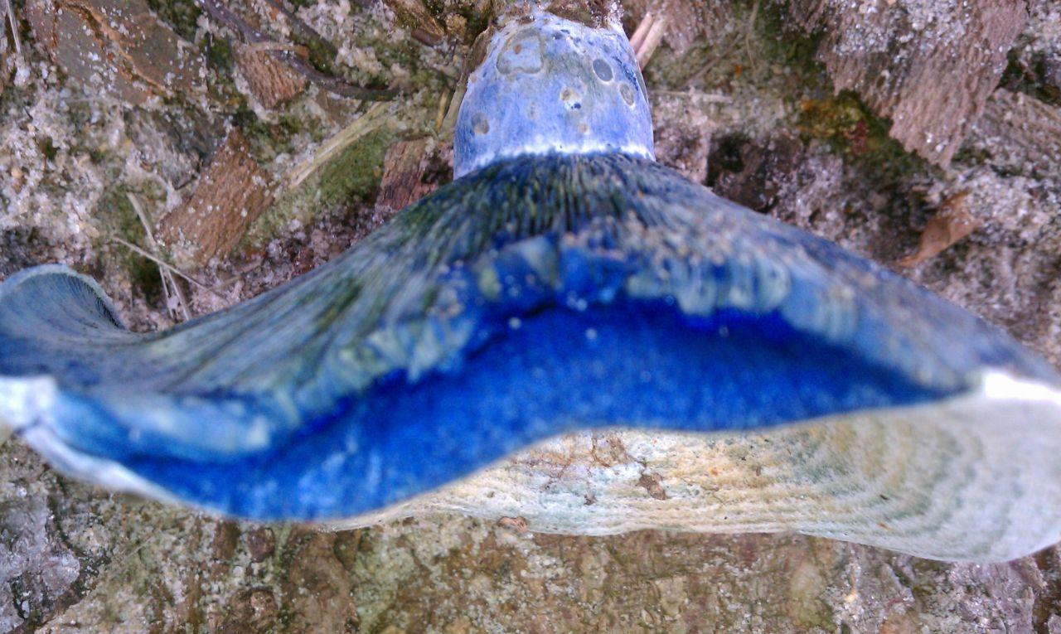

Seeds of Wisdom Team
Your Community
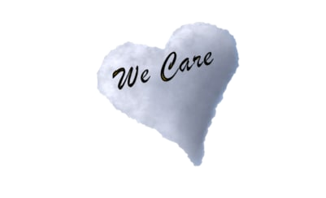
https://seedsofwisdomteam.com

Mushroom photos by JJ Smith in the art room

MUSHROOMS MARKZ IS NOT ENDORSING ANY PRODUCT
Research into each one and you will find so much information

Natural Blaze: JJ Smith found
Film: Mushrooms Heal You and The Planet!
https://www.naturalblaze.com/2019/08/film-mushrooms-heal-you-and-the-planet.html

Natural News: JJ Smith
Better than bone broth? Many health gurus are switching to mushroom broth
https://www.naturalnews.com/2019-07-16-many-health-gurus-are-switching-to-mushroom-broth.html

Turkey tail mushroom
https://www.healthline.com/nutrition/turkey-tail-mushroom

Chaga
https://www.disabled-world.com/fitness/nutrition/chaga.php

Rick Simpson story RSO
Full version
https://www.youtube.com/watch?v=V1UqdL7sgBM

Some places to Purchase
http://www.phoenixtears.ca/

Amazon Lions mane

Organic Lion's Mane Mushroom Capsules - 2100 mg Max Capsule Dose + Absorption Enhancer
by DR EMIL NUTRITION

Four Sigmatic Mushroom Coffee with Lion’s Mane & Chaga For Concentration + Focus, Vegan, Paleo, Gluten Free, 0.09 Ounce (10 Count)
https://www.amazon.com/s?k=mushroom+coffee&ref=nb_sb_noss_2

Pure Lion's Mane™ - Aloha Medicinal

Solaray - Mushroom Complete 8 - on Amazon https://www.amazon.com/s?k=Solaray+-+Mushroom+Complete+8+-+on+Amazon.
Contains eight mushrooms: oyster, cordyceps, turkey tail, royal agaricus, lion's mane, shiitake, maitake and rishi. Potent supplement that can support a healthy immune system May help lower high levels of bad (LDL) cholesterol

NEW ON MUSHROOMS JJ Smith
http://healthimpactnews.com/2019/reishi-mushrooms-fight-inflammation-and-cancer/

MICRO DOZING RESEARCHING
Buckley fountain
https://beckleyfoundation.org/microdosing-lsd/

NCBI
https://www.ncbi.nlm.nih.gov/pmc/articles/PMC6364961/

