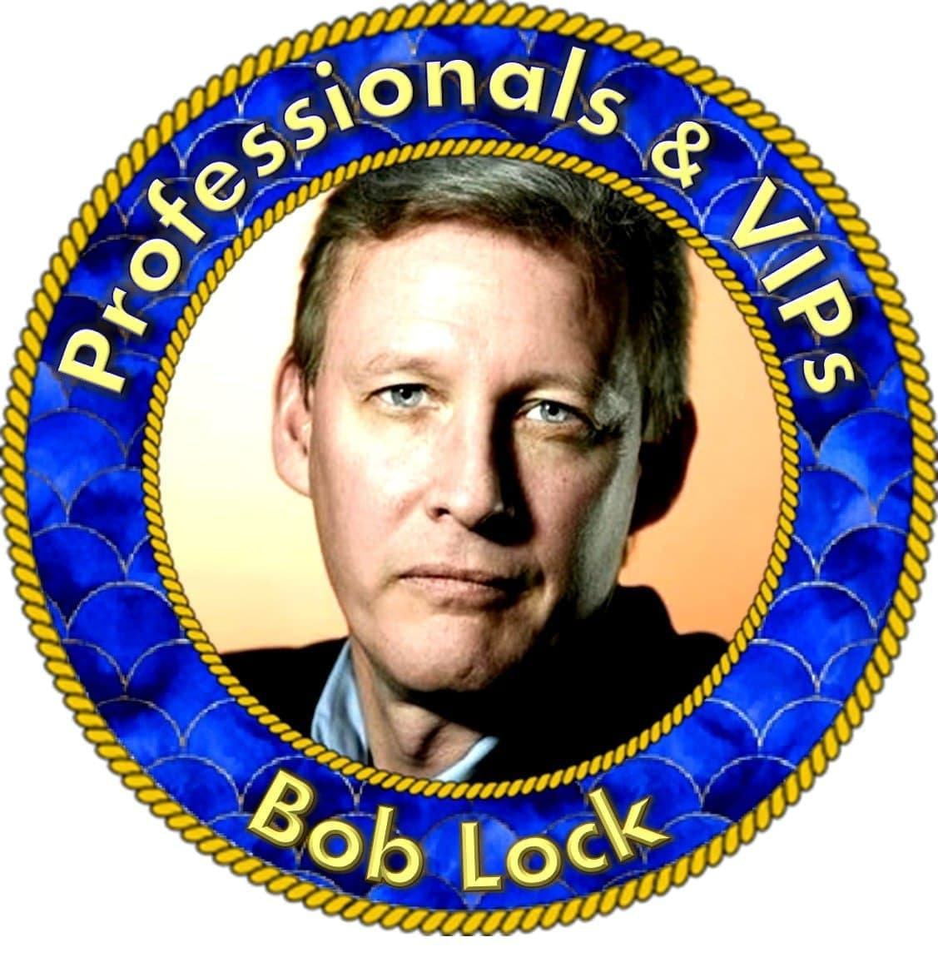
Bob Lock
Bob Lock's Pro Room
https://t.me/+Sx5ptSr4khfQ7CAz

Notes/ Q&A

A MOMENT OF WISDOM WITH BOB

From the desk of Bob Lock:

"Anyone in the community can Direct Message me at any time."
I appreciate how one thread leads into another thread, but I would like to stick to topics that relate directly to the logistics of trusts and our appointments please

I'll be posting here in chat about everything that
I can related to the appointment and afterwards.

I take every estimate of exchange/redemption rates with a grain of salt at this point.
We’ll know when we get there and not before

Hello All! I hope that you are all having a great day. Please guard your mental and emotional health as we await our appointments. I used to ride an emotional roller coaster due to the shifting timelines associated with the transition to the new systems. The constant hurry up and wait wears on you and is not healthy. Things are moving, and we will get there. But it is not in our time. Our job is to be prepared and educate ourselves so that when it does happen, we are ready. If you find yourself getting frustrated while waiting, jump up to the attached educational materials and make ready. Then, read your trust materials all the way through. We will get there!

I encourage you all to stop riding the emotional roller coaster that surrounds this RV/GCR event. It is hard to do, especially when you are struggling with immediate financial needs, but you need to do it for your mental and emotional health. Huge changes are happening all around us. Look past the Russia/Ukraine smokescreen that the MSM is blasting out 24/7. The SWIFT system is collapsing and the CIPS system is set to replace it as countries act to replace the USD reserve currency status. The Durham investigation and the Hunter Biden Grand Jury are operating without interruption. All will become clear sooner than you expect. I can tell you that from people who I have spoken with that there is a flurry of activity proceeding behind the scenes to get us to our appointments. I am restricted as to details, but have no doubt in my mind that it is coming, and can not be stopped.

I have taken the time to create a packet of materials that is geared towards your appointments. The end result is a Common Law Express Contract Trust Organization. The materials will include a Declaration of Trust, Articles of Organization, Organization Purpose & Intent, Trustee Authorization letters, Certificate of Trust, Minutes of Meetings and Schedules. And I have taken great pains to make it affordable for everyone in this community

Since we are going to be operating in a system based on the USN managed by the QFS, my fear of wealth managers and bankers has diminished a great deal. There is nothing that I have ever heard to support the idea that anyone would be penalized for not using a trust at their appointment. The trust is for your benefit, in terms of privacy, shielding from liability, and probate and estate tax issues, but it is not required.

Remember that the states are just corporations whose systems are based on the FIAT dollar. When the systems change all those corporations go away and so do their taxes.

FYI To All:

If you have a question about the RV/GCR, or currency, rates, etc., please ask those questions in the Currency News Banking chat room here on Telegram. It keeps things more compartmentalized and easier for others to follow. Here, we focus on managing trusts, and preparing to navigate our trusts through our appointments. Thank You for understanding.

There is no requirement that anyone have a trust to exchange. There is a question as to whether one is required to get a higher rate for projects. Mark Z is correct when he says that. He also makes it clear that he has a trust set up, which he got from me. So while you do not have to have one, if you are exchanging/redeeming large quantities of funds, trusts make complete sense.

I take every estimate of exchange/redemption rates with a grain of salt at this point. We’ll know when we get there and not before

A MOMENT OF WISDOM WITH BOB LOCK

No one should stop living their lives while riding an emotional roller coaster waiting for our appointments to come. Understand that once we get the notice we have time to make our appointments. So even if you are out of town, you can make it for when you get back and settled. There is nothing to stress about.

A MOMENT OF WISDOM WITH BOB LOCK

No one should stop living their lives while riding an emotional roller coaster waiting for our appointments to come. Understand that once we get the notice we have time to make our appointments. So even if you are out of town, you can make it for when you get back and settled. There is nothing to stress about.

MOMENTS OF WISDOM FROM BOB LOCK

QUESTION: Will I be able to change my Grantor name after funding my Trust?

ANSWER: Absolutely. It’s just a matter of a meeting and minutes. Same with changing address or trust name

MOMENTS OF WISDOM FROM BOB LOCK

QUESTION: What is the difference between Common Law Trust and other trusts?

ANSWER: I would suggest reading through the materials PINNED to the top of my room and go to the SOW web site to set a foundation of knowledge to start with.

Webstite:
https://seedsofwisdomteam.com/trusts

MOMENTS OF WISDOM FROM BOB LOCK

QUESTION: Is there a Trust Management Company you recommend?

ANSWER: I will probably end up at some point engaging with a professional corporate trust management company like Northern Trust or something similar. They have a ton of resources in house that allow them to cover whatever your trust business and projects are.

Webstite:
https://seedsofwisdomteam.com/trusts

MOMENTS OF WISDOM FROM BOB LOCK

QUESTION: Will we be able to exchange/redeem using a CRT Charitable Religious Trust or do we need to have a Revocable Trust as suggested by Ed?

ANSWER: A CRT is absolutely fine for the appointment.

Webstite:
https://seedsofwisdomteam.com/trusts

Bernie Besherse Posted

Bob is a lawyer, and Bob is a good man.
When you find some man who is both a lawyer AND a good man, you have one of the best kinds of men. Bernie Besherse

MOMENTS OF WISDOM FROM BOB LOCK

QUESTION: Does schedule A have to be filled out before the exchange or during the exchange?

ANSWER: Schedule A is completed for when the trust is signed and notarized.

Webstite:
https://seedsofwisdomteam.com/trusts

MOMENTS OF WISDOM FROM BOB LOCK

QUESTION: I listed on Schedule A - "VARIOUS FOREIGN CURRENCIES AND BONDS ". Is that acceptable?

ANSWER: That is good to start. Ideally you can add some detail post exchange. Some people just list currency type and face amounts

Webstite:
https://seedsofwisdomteam.com/trusts

MOMENTS OF WISDOM FROM BOB LOCK

QUESTION: How soon after notification happens, are you planning on going in for your exchange appointment?

ANSWER: I’ll be calling to schedule my appointment right away, and looking for an appointment two days out from my call. As for the Zim, I have seen supposed deadlines change so I anticipate that possibly changing again. Whatever it is, I will adjust.

Webstite:
https://seedsofwisdomteam.com/trusts

MOMENTS OF WISDOM FROM BOB LOCK

QUESTION: On sub-trusts for real estate or vehicles are those stand-alone trusts?

ANSWER: You can go either way with stand alone or under the main trust. Both trusts are separate entities that won’t allow a successful attack on the main trust.

Webstite:
https://seedsofwisdomteam.com/trusts

MOMENTS OF WISDOM FROM BOB LOCK

QUESTION: Why would it be important to have the trust prior to going to the exchange?

ANSWER: There is a ton of educational materials here and on the Seeds of Wisdom web site. For me, I created a trust beforehand because it affords me privacy, limited liability, as well as probate and estate tax benefits.

Webstite:
https://seedsofwisdomteam.com/trusts

MOMENTS OF WISDOM FROM BOB LOCK

QUESTION: How do I get information about your Common Law Trust?

ANSWER: Send me an email to debtlawyer@gmail.com and I can send you some information.

Webstite:
https://seedsofwisdomteam.com/trusts

MOMENTS OF WISDOM FROM BOB LOCK

QUESTION: Where can I find the Weiss Trustee Handbook document?

ANSWER: You can find it in my docs by clicking this link: https://drive.google.com/drive/folders/1PtqDqGdCno9oiXvLTRBrebz-0ydRrA7C?ths=true

Webstite:
https://seedsofwisdomteam.com/trusts

Remember that the states are just corporations whose systems are based on the FIAT dollar. When the systems change all those corporations go away and so do their taxes.

I appreciate how one thread leads into another thread, but I would like to stick to topics that relate directly to the logistics of trusts and our appointments please.

MOMENTS OF WISDOM FROM BOB LOCK

QUESTION: Will I be able to get a proof of funds letter from the bankers if I am just redeeming on my first appointment. Don't need money just the letter.

ANSWER: You will absolutely be able to get as many of those as you want.

Webstite:
https://seedsofwisdomteam.com/trusts

MOMENTS OF WISDOM FROM BOB LOCK

QUESTION: Do you think it’s better privacy protection if I also change the address of my trust in the minutes to a mailroom address? Or will that alert my mailroom of the trust’s name, it’s existence?

ANSWER: Many people use PO boxes and private mail drops. The mailroom knows that the trust exists, but not who it is.

Webstite:
https://seedsofwisdomteam.com/trusts

MOMENTS OF WISDOM FROM BOB LOCK

QUESTION: how would we handle giving tithes and offerings when we can't let anyone know we have the money? Even if the trust sends the church a check, if it's tons of money they would know somebody RVed. How does any of that work without getting found out when you want to keep the Lord first?

ANSWER: Unless someone told them about the RV/GCR, the overwhelming majority of people would have no idea where the money comes from. And the trust can always donate anonymously.

Webstite:
https://seedsofwisdomteam.com/trusts

MOMENTS OF WISDOM FROM BOB LOCK

QUESTION: Would I use the same trust that I set up for the exchange or should I put the new home I purchase in a new trust.

ANSWER: My rule of thumb is to put any major asset into its own trust for privacy and liability protection, as well as the probate and estate tax benefits.

Webstite:
https://seedsofwisdomteam.com/trusts

MOMENTS OF WISDOM FROM BOB LOCK

QUESTION: At the RC do you think it’s a reasonable ask to have the redemption bank move small amts of money to your personal “pay the bills” bank account over time? Like asking for an auto deposit of $5000 every two weeks (almost like direct depositing a paycheck) from an “personal funds payout” account held by the trust and place a meeting minute after the RV that the Grantor/Trustee (who are one and the same) approving it?

ANSWER: I will be operating as trustee and will instruct the bank to send funds every month to my personal account for fees and expenses.

Webstite:
https://seedsofwisdomteam.com/trusts

MOMENTS OF WISDOM FROM BOB LOCK

QUESTION: Would you mind elaborating on the potential need to exchange some currency into a personal account vs exchanging everything into the CL trust?

ANSWER: Since it is revocable the grantor can withdraw from the trust, subject to whatever the existing tax laws dictate.

Webstite:
https://seedsofwisdomteam.com/trusts

MOMENTS OF WISDOM FROM BOB LOCK

QUESTION: (Trustee powers in the trust) We carefully excluded 4, only to find unlimited powers in the certification of trust. I used the sample revocable docs and cert. I have it all set up and notarized. Will it be an issue? Can a trust attorney aid in tweaking both After the exchange?

ANSWER: If you’re talking about the DIY trust I am afraid that I have not had the opportunity to review it and thus can’t comment on it.

Webstite:
https://seedsofwisdomteam.com/trusts

MOMENTS OF WISDOM FROM BOB LOCK

QUESTION: Bob do all monies need to be put into the trust at exchange ?

ANSWER: The grantor determines what to put into the trust.

Webstite:
https://seedsofwisdomteam.com/trusts

MOMENTS OF WISDOM FROM BOB LOCK

QUESTION: Bob, do all monies need to be put into the trust at exchange ?

ANSWER: The grantor determines what to put into the trust.

Webstite:
https://seedsofwisdomteam.com/trusts

MOMENTS OF WISDOM FROM BOB LOCK

QUESTION: I don’t technically have a salary from my trust but my minutes say the trustee can cover minimal expenses until the trust is formally revised with the help of a trust team.

ANSWER: Trustees generally receive fees of anywhere from 0.5-2.0% of assets under management plus expenses associated with their work on behalf of the trust.

Webstite:
https://seedsofwisdomteam.com/trusts

MOMENTS OF WISDOM FROM BOB LOCK

QUESTION: I rented a new P.O. Box today closer to my house. Can I just document the change of mailing address for my trust in the minutes? Then take a copy of those specific minutes to redemption/exchange?

ANSWER: Yes, that is precisely what to do.

Webstite:
https://seedsofwisdomteam.com/trusts

MOMENTS OF WISDOM FROM BOB LOCK

QUESTION: After saying we didn’t need a trust, MarkZ says he has one done by you? Do we need trust before RV?

ANSWER: Mark is being truthful. There is no requirement that you have a trust but Mark and many others, myself included, have them for the numerous significant benefits they provide.

Webstite:
https://seedsofwisdomteam.com/trusts

MOMENTS OF WISDOM FROM BOB LOCK

QUESTION: Are trusts different in each state?

ANSWER: Statutory trusts are different from state to state. Common law trusts are based on the same common law principles and so should not change much from state to state. As for documentation, there is a wealth of educational materials.

_________________________________________________

QUESTION: Looks like I'll be moving out of California. Will your trust here be ok in AZ even though notarized in CA. I assume it's not that complicated.

ANSWER: You can change the address for the trust but everything else will work fine.

__________________________________________________

QUESTION: I have a LRTrust for the RV. I am in a blue tax heavy state. Could I establish a new Trust out of a red no tax state after the RV happens?

ANSWER: You can absolutely do that. I would wait until the dust settles.

_________________________________________________

QUESTION: One investment I’m planning to make is funding an annuity payable to me as a future income stream. Could those annuity payments be made to me as an individual or would they have to flow into a trust? Or do we even know yet what the requirements will be?

ANSWER: That’s a question that you will ask at your wealth advisor meeting. It’s impossible to speculate on specifics before our appointments. It is just conjecture.

_______________________________________________

QUESTION: How do trusts change once NESARA takes affect?

ANSWER: Statutory trusts will need to be amended to reflect the transition to common law.

_________________________________________________

COMMENT: I am currently working on correcting an EIN error 101 will keep you updated!

ANSWER: 101 Error message is usually because the name in the application is the same or very similar to a trust name already in their system. I add something like the year (2022) or letters or numbers and the application goes through.
_________________________________________________
QUESTION: How can I have you set up a trust for me.

ANSWER: Please send me an email to debtlawyer@gmail.com and I’ll send you some information.
________________________________________________
QUESTION: How do we receive personal funds at the exchange to take care of bills, for urgent needs of family members, etc?

ANSWER: It’s a simple matter of not putting everything into the trust for your appointment. Whatever you hold out of the trust you can exchange personally for non-trust related matters.

_________________________________________________

